# Assignment 1& 2

**Assignment 1:Create an infographic illustrating the Test-Driven Development (TDD) process. Highlight steps like writing tests before code, benefits such as bug reduction, and how it fosters software reliability.**

# Ans:

**Flowchart depicting the Test-Driven Development (TDD) process:**

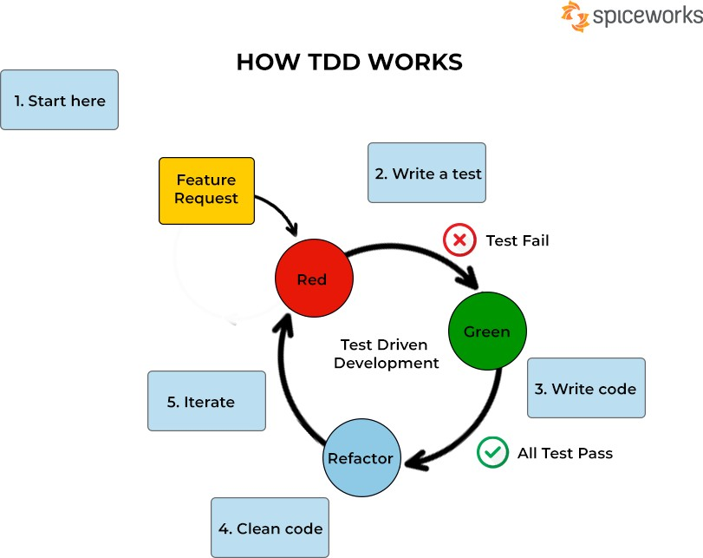

# Write Tests

* + Developers write small, specific automated tests based on user stories or requirements.

# Run Tests

* + Execute the tests to ensure they fail initially, indicating that there is no code to

fulfill the requirements yet.

# Write Code

* + Develop the minimum code necessary to pass the failing tests. This code is often referred to as the "implementation code."

# Run Tests Again

* + Execute the tests again. They should pass now as the minimal implementation code has been written.

# Refactor Code

* + Optimize and refactor both the implementation code and the test code to improve readability, maintainability, and performance.

# Benefits of Test-Driven Development (TDD):

* **Bug Reduction:** TDD helps catch and fix bugs early in the development process, reducing the likelihood of bugs reaching production and minimizing overall debugging time.
* **Improved Software Reliability:** By continuously testing and verifying the functionality of the codebase, TDD fosters software reliability and ensures that the

software behaves as expected.

* **Faster Development:** Despite the initial investment in writing tests, TDD can lead to faster development cycles by encouraging developers to focus on delivering only the necessary functionality and preventing time-consuming debugging later on.

# Conclusion:

Test-Driven Development (TDD) promotes a disciplined and iterative approach to

software development, where tests drive the implementation and code quality is paramount. By following the TDD process, developers can create more reliable, maintainable, and bug-free software products.

# Illustration of a developer writing tests before writing code:

**Writing Test :**



# Writing Code:

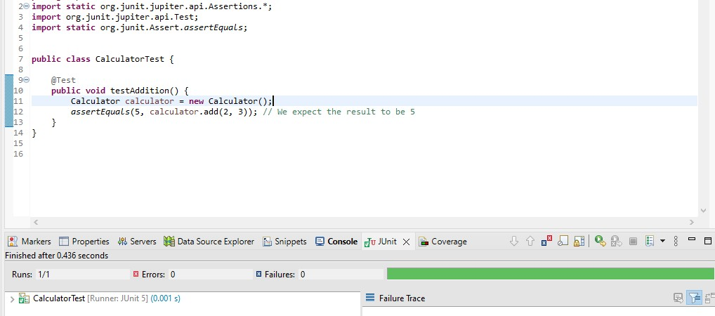

**Assignment 2: Produce a comparative infographic of TDD, BDD, and FDD methodologies. Illustrate their unique approaches, benefits, and suitability for different software development contexts. Use visuals to enhance understanding.**

# Ans:

1. **Test-Driven Development (TDD)**

# Approach:

* + - Write tests before writing implementation code.
    - Tests are written to cover specific requirements or user stories.

# Benefits:

* + - Early bug detection and prevention.
    - Improved code quality and design.
    - Ensures code is testable and maintainable.

# Suitability:

* + - Ideal for projects with clear and well-defined requirements.
    - Works well for small, iterative development cycles.

# Developer writing tests before code:

**Writing Test:**



# Writing Code:





1. **Behavior-Driven Development (BDD)**

# Approach:

* + - Focuses on defining behavior in terms of user stories.
    - Uses natural language specifications to describe desired behavior.
    - Tests are written from the perspective of end-users.

# Benefits:

* + - Encourages collaboration between developers, testers, and stakeholders.
    - Improves communication and understanding of requirements.
    - Promotes a customer-centric approach to development.

# Suitability:

* + - Well-suited for projects with complex business logic and varied stakeholder requirements.
    - Effective for teams practicing continuous integration and delivery.

# Team discussing user stories:

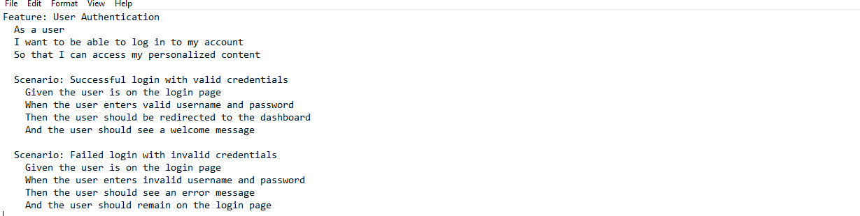

1. **Feature-Driven Development (FDD)**

# Approach:

* + - Focuses on delivering features iteratively.
    - Features are broken down into smaller, manageable tasks.
    - Emphasizes domain modeling and feature prioritization.

# Benefits:

* + - Encourages a feature-centric approach to development.
    - Promotes incremental delivery and feedback gathering.
    - Provides a clear framework for managing project scope and progress.

# Suitability:

* + - Suitable for large-scale projects with complex requirements.
    - Effective for teams with a focus on feature delivery and client satisfaction.

# Team working on feature breakdown:

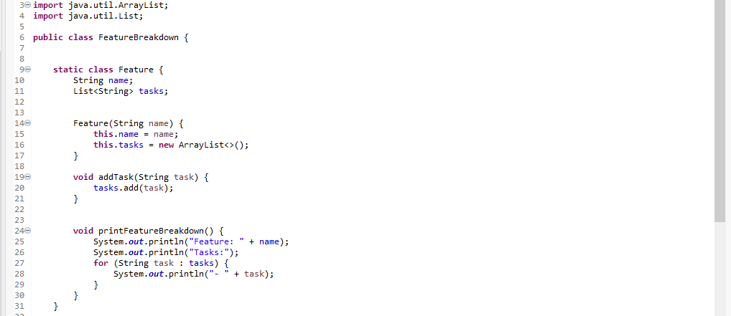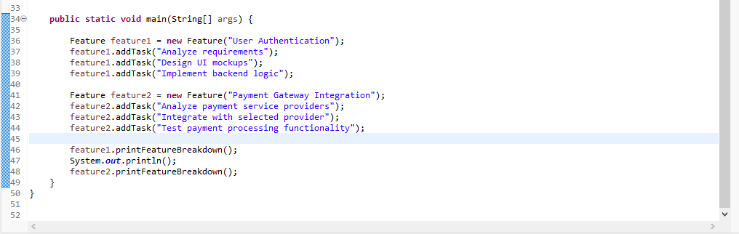

**Conclusion:**

* + Each methodology offers unique approaches to software development, catering to different project needs and team dynamics.
  + Choosing the right methodology depends on factors such as project complexity, team size, and stakeholder requirements.
  + Regardless of the chosen methodology, the key is to prioritize collaboration, communication, and delivering value to end-users.